**WEEK-2**

**TDD Using Junit5 and Mockito: JUnit_Basic Testing Exercises:**

**EXERCISE 1: Setting Up JUnit**

**Step 1:** Create a Maven Project in Eclipse.

**Step 2:** Create a file Calculator.java

package junitdemo;

public class Calculator {

public int add(int a, int b) {

return a + b;

}

public int subtract(int a, int b) {

return a - b;

}

public int multiply(int a, int b) {

return a * b;

}

public int divide(int a, int b) {

if (b == 0) throw new IllegalArgumentException("Cannot divide by zero");

return a / b;

}

public int square(int a) {

return a * a;

}

}

**Step 3:** Create a test file CalculatorTest.java

package junitdemo;

import org.junit.Test;

import static org.junit.Assert.*;

public class CalculatorTest {

Calculator calc = new Calculator();

*@Test*

public void testAdditionPositive() {

*assertEquals*(10, calc.add(6, 4));

}

*@Test*

public void testAdditionNegative() {

*assertEquals*(-5, calc.add(-3, -2));

}

*@Test*

public void testSubtraction() {

*assertEquals*(2, calc.subtract(5, 3));

}

*@Test*

public void testSubtractionNegativeResult() {

*assertEquals*(-1, calc.subtract(2, 3));

}

*@Test*

public void testMultiplication() {

*assertEquals*(15, calc.multiply(3, 5));

}

*@Test*

public void testMultiplicationWithZero() {

*assertEquals*(0, calc.multiply(0, 100));

}

*@Test*

public void testDivision() {

*assertEquals*(4, calc.divide(8, 2));

}

*@Test*(expected = IllegalArgumentException.class)

public void testDivisionByZero() {

calc.divide(10, 0);

}

*@Test*

public void testSquarePositive() {

*assertEquals*(49, calc.square(7));

}

*@Test*

public void testSquareNegative() {

*assertEquals*(25, calc.square(-5));

}

}

**OUTPUT:**

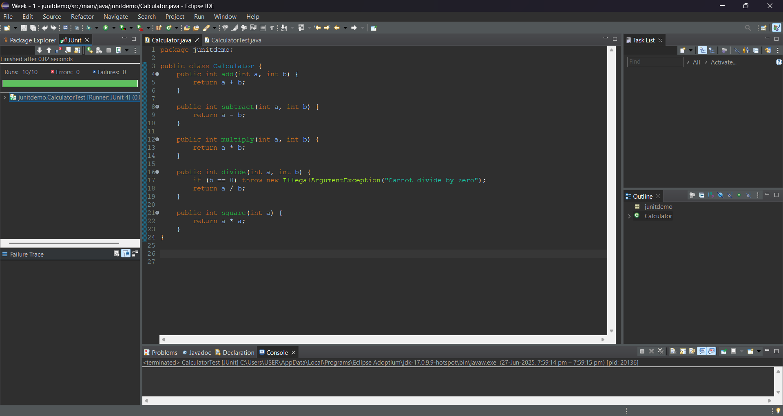

**EXERCISE 3: ASSERTIONS IN JUnit**

**Step 1 :** Create anew Maven Project in Eclipse.

**Step 2:** Create a class SampleAssertions.java

package com.assertion;

public class SampleAssertions {

public int getSum(int a, int b) {

return a + b;

}

public boolean isPositive(int number) {

return number > 0;

}

public boolean isNegative(int number) {

return number < 0;

}

public String getNullString() {

return null;

}

public String getNotNullString() {

return "Hello";

}

}

Step 3: Create a test file AssertionsTest.java

package com.assertion;

import org.junit.Test;

import static org.junit.Assert.*;

public class AssertionsTest {

SampleAssertions sa = new SampleAssertions();

*@Test*

public void testSum() {

*assertEquals*(15, sa.getSum(10, 5));

}

*@Test*

public void testIsPositive() {

*assertTrue*(sa.isPositive(7));

}

*@Test*

public void testIsNegative() {

*assertFalse*(sa.isPositive(-1));

}

*@Test*

public void testNullString() {

*assertNull*(sa.getNullString());

}

*@Test*

public void testNotNullString() {

*assertNotNull*(sa.getNotNullString());

}

}

**OUTPUT:**

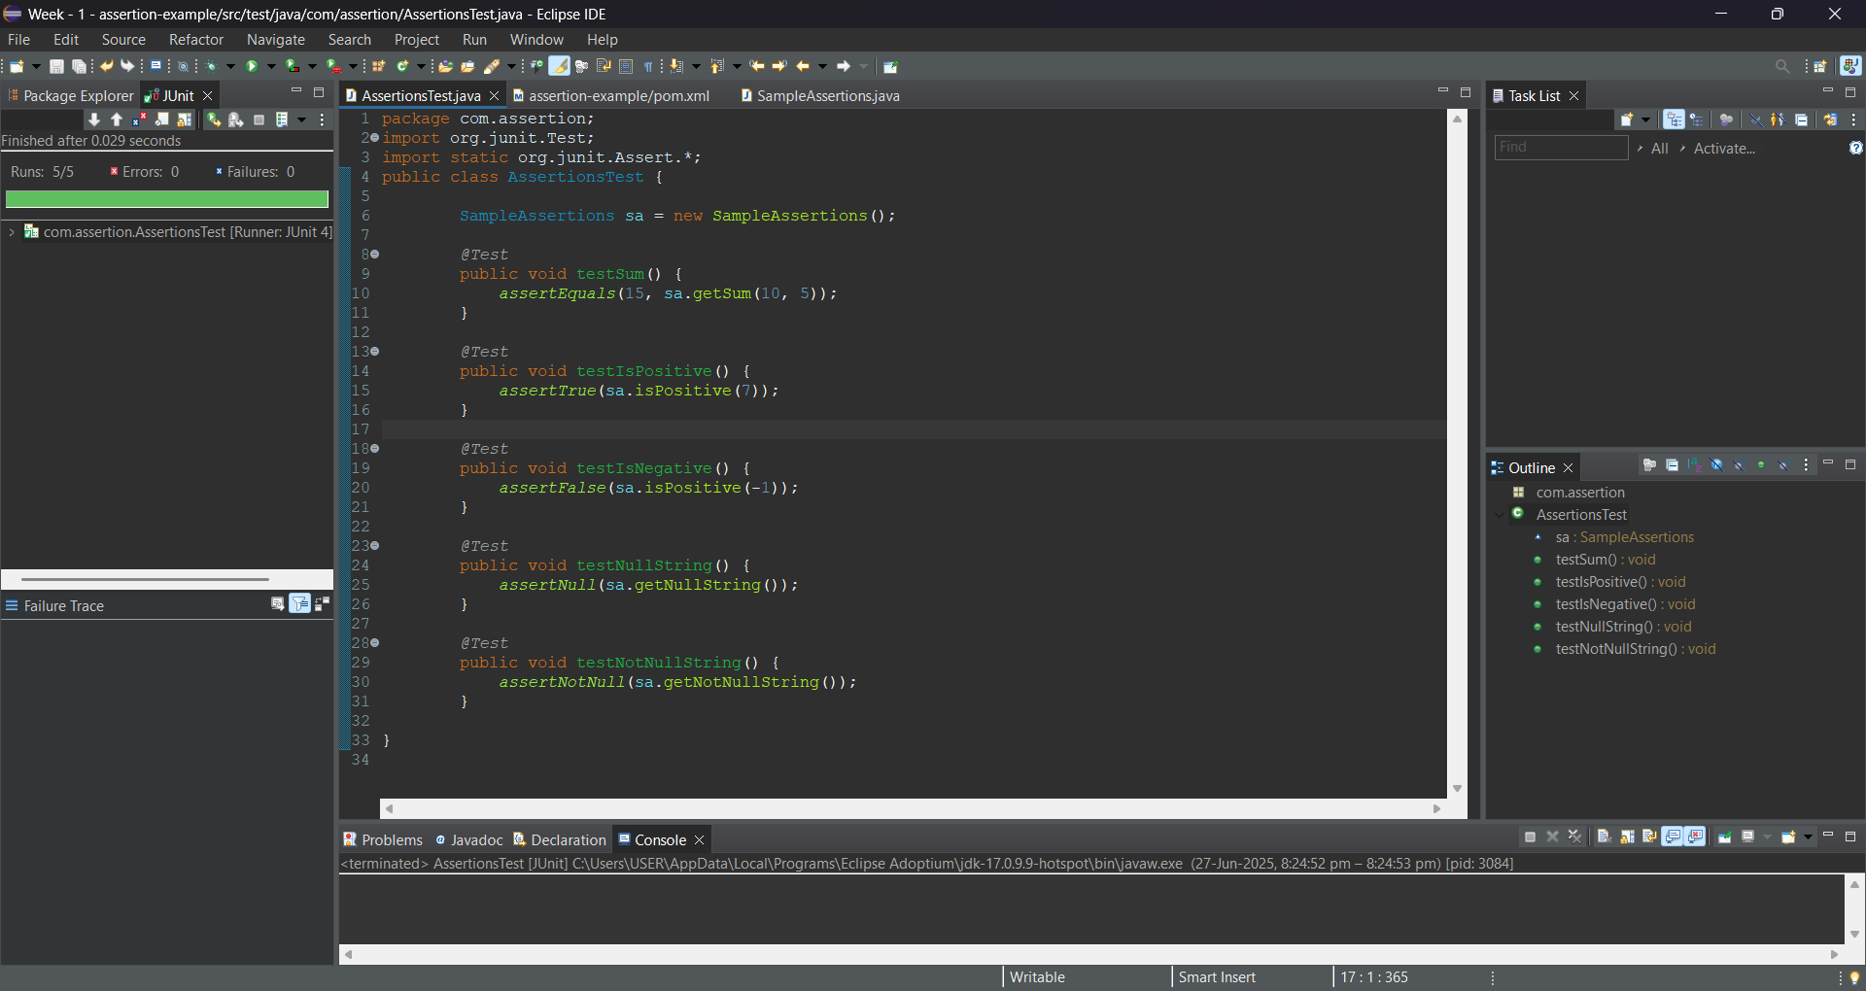

**EXERCISE 4: ARRANGE-ACT-ASSERT (AAA) PATTERN WITH SETUP AND TEARDOWN** **IN** **JUNIT**

**Step 1:** Create a Java Maven Project.

**Step 2:** Create a Main class – Calculator.java

package junitexercise;

public class Calculator {

public int add(int a, int b) {

return a + b;

}

public int multiply(int a, int b) {

return a * b;

}

}

**Step 3:** Create a Test file – CalculatorTest.java

package junitexercise;

import org.junit.After;

import org.junit.Before;

import org.junit.Test;

import static org.junit.Assert.*;

public class CalculatorTest {

Calculator calc;

*@Before*

public void setUp() {

System.***out***.println("Setting up Calculator...");

calc = new Calculator();

}

*@After*

public void tearDown() {

System.***out***.println("Tearing down Calculator...\n");

calc = null;

}

*@Test*

public void testAdd() {

// Arrange

int a = 5, b = 3;

// Act

int result = calc.add(a, b);

// Assert

*assertEquals*(8, result);

}

*@Test*

public void testMultiply() {

// Arrange

int x = 4, y = 2;

// Act

int result = calc.multiply(x, y);

// Assert

*assertEquals*(8, result);

}

}

**OUTPUT:**

